**DINH THI QUYEN**

Supervisor: **DO QUOC BINH**

November 2020

**Development Read and Write App**

**An environment of freedom of exchange and sharing for those who are passionate about reading stories and writing creek**

ABSTRACT

PREFACE

The product of this project is Read And Write App (R&W) will be a freedom environment which will be created to allow user to write and read Book or stories

Acknowledgements

During the implementation of this project, I received feedback and evaluation from my tutor who is Mr. Doan Trung Tung and Mr. Do Quoc Binh.

Contents

ABSTRACT 2

PREFACE 3

Acknowledgements 4

I. Introduction 8

II. Literature review 9

1. Overview 9

2. E-books and traditional books 9

2.1 Traditional books 9

2.2 E-books 10

2.3 Compare between type of books 16

3. Technology 16

3.1 Android app 16

3.1.1 Definition: Android operation system and android apps 16

3.1.2 Why I choose android for my project 16

3.2 Backend technologies 17

3.2.1 Java 17

3.2.2 Kotlin 18

3.2.3 Python 20

3.3 Font-end technologies 20

3.3.1 Kotlin 20

3.3.2 Java 20

3.3.3 React native 20

3.4 Choosing program language 20

3.5 Database language 20

3.5.1 SQL 20

3.5.2 Mogo DB 20

3.5.3 Choosing database language 21

3.6 Tool 21

3.6.1 Android studio 21

3.6.2 Visual Studio Code 21

3.6.3 GitHub 21

3.6.4 MySQL 21

3.6.5 Draw.io 21

4 Methodology 21

4.1 Waterfall model 21

4.2 Scrum model 22

4.3 Choosing methodology 24

III. Other Ebook product 25

1. E-books on website 25

1.1 Facebook 25

1.2 Wordpress 25

2 Similar apps 25

2.1 Wattpad Apps 25

2.1.1 Overview 25

2.1.2 History of Wattpad 26

2.1.3 Problem of Wattpad app 27

2.2 FBReader 27

2.3 Kobo Books 28

2.4 Amazon Kindie App 28

2.5 Bluefire Reader App 28

2.6 Apple Books App 28

2.7 Evaluation and conclusion 29

Bibliography 30

# Introduction

Books are a limitless source of human knowledge accumulated over hundreds of years as a precious treasure of humanity, and readers are looking for it. It is also the way that people store cultural values ​​through the ages. That's why reading is a very essential and important. It is a way for people to learn and improve themselves. Because of that, the purpose of this project is to create freedom environment where books and stories can be read and shared with the community. The product of this project will be the place where the book's values ​​are lived out in time, and the reader can also become the author who writes his / her story. It will also be a tool to draw the author's distance from the reader community to be closer through direct comments and exchanges in each story they post. Through this product, hoping that it will contribute to the development of everyone's reading habits.

The product is called the Read and Write App and is abbreviated as R&W. To be able to realize this idea I opted to use Python's Flask framework for back-end development for my application. This framework makes it easier for developers to create web applications that are easier, scalable, efficient, and maintainable by providing code or code-usable extensions. At the same time, I use react native to build skins for this app. This is a framework that can help build both Android and iOS apps. Not only choosing the right technology to make project being successful, but I also choose Waterfall to manage this project. This helps me avoid errors and manage risks during project implementation.

Below is my research document covering the ingredients (such as technology, design, planning), the product building process (such as analysis data and implement program), and the product that I come up with in the process.

# Literature review

# Overview

In this project, there are an app which will be created to allow user to write and read eBook or stories. So, studying about eBooks and some similar product is necessary to complete project’s idea and assess the feasibility of the project:

# E-books and traditional books

## Traditional books

According to

**Advantages**

Printed book offers many benefits for the reader, one of which is that the reader does not need an e-reading device or a computer, an iPad, or a smartphone so it is suitable for everyone. They can read books without worrying whether the battery is sufficient or not. Readers can easily understand what author wrote by the way is markers or notes. Printed books are physical and tangibility so readers can touch, hold, and permanently see them on their bookshelf. (Lipovac, 2014)

**Disadvantages**

Although printed book brings many benefits to the reader, it also causes some disadvantages for the reader. It will be inconvenient if readers need to be going far away or in situations which it is impossible to carry heavy packages and cumbersome because the book will take up a lot of space and have quite a large weight. Not only during long trips, books also take up a large space in the house if you want to store them. And it is evident when reading a book that readers need light to be able to see and read them. They can't read books in the dark. (Lipovac, 2014)

## E-books

According to (wikipedia, n.d.), E-book or eBook stand for electronic book is a book including text, images or both which made available in digital form. Those books can display on flat-panel of computer or other electronic devices to read for example, e-reader devices, laptops, tablets, smartphone and computer.

**History of e-books**

Nowadays, with the explosion of internet, the development of e-books is more and more remarkable. Publishing, buying and reading e-books is becoming easier. More and more users are interested in reading e-books than possible because of the low cost, convenience and comfort of reading anywhere. Despite the popularity of the e-book, most people don't think its history dates back to before World War II with Vannevar Bush who thought that the memex like a way for individuals store and read available information, and eBook’s history probably originated in the early computers.

According to (Holley, 2012), In 1945, Vannevar Bush officially introduced the idea of ​​an electronic book in the essay ‘As We May Think’ to the community of scientists. In this essay, Bush presented that this idea stems from the difficulties that he and other researchers faced when searching for different information, documents, and conclusions. Therefore, he wanted to create a personal device to store information to make research easier. This idea was cherished and written in the late 1930s but it wasn't published until 1945. Brush left Cambridge to Carnegie Foundation to work with three graduate students on the memex project. After a period of research and implementation according to the plan, Bush’s product was not achieved as expected. The machine created that was called '' Rapid Selector, '' spreads over a large room. Although it wasn't individual machine, it inspired Alan Kay, Douglas Englebart and Ted Nelson to be able to create the first computer device and make Bush's concept what we know now.

According to (Holley, 2012), It wasn't until nearly 30 years later in 1969 that Bush's ideas just began to be conceived by Alan Kay. He gave an initial presentation of a personal computer in his essay. As the leader of the Xerox Palo Alto Research Center (XeroxPARC), Kay encourages and brings together a group of like-minded people to study. However, technology at that time did not keep up with his ideas. During this time, he was working with children's learning software and came up with the idea of ​​creating devices that could represent, communicate, and animate words, pictures and sounds. He also mentioned about the animation could be on the screen and gives its potential boost over the book. Therefore, he studied to make a language which known as SmallTalk.

While the idea of ​​Kay's eBook hardware was still in its infancy, Michael Hart came up with the idea to scrape the electronic library and start Project Gutenberg on the Xerox Sigma V. Hart thought that the best purpose of computer was the storage and retrieval of information from many different computers through the ASCII text. This way, 99% of computers worldwide cannot access the file. After a long period of development from 1971 until 2010, this project provided 37,500 title of books. (Holley, 2012)

The advancement of technology also fueled the eBook. One of the technologies that has enhanced the usability of the eBook was the SuperBook, which was created by Bell Communication. This software processes the text so it can be formatted like a book with title, table of contents, page, word look. It can also search all occurrences of a word through indexes and Boolean. Following that in 1989, Book Manager written by General Markup Language was introduced by IBM. This software allows viewing of files on multiple platforms and it has Book Manager BUILD for creating books that are used by Book Manager READ to display, search, manage books and bookshelves. (Holley, 2012)

With the popularity of e-books, a compact product (1.5 pounds, display 30 characters by 10 lines) can not only store 200,000 pages of text, but can also play both audio CDs and 8 cm CD- ROMs have been released by Sony. This product is called Data Discman. After its introduction at the end of 1991, it has gained much success in the Japanese, American market, etc. Then Sony also developed Bookman (2 pounds), and collaborated with Microsoft to develop it. Since then a series of eBook products have been released: in 1998, the SoftBook Reader was introduced by the Soft Book Press (9 '' x12 '' inches and weighs three pounds); This same year Roket eBook was relesed by NuvoMedia. In 1999, EveryBook was introduced by World Electronics and Microsoft applied ClearType technology to improve Microsoft Reader's poor reading. (Holley, 2012)

From 2000s to now, eBook readers has made many great developments such as: Stephen King's Riding the Bullet book was the first electronic exclusively released online; Palm Reader e-books was introduced in 2002 with more than 5000 eBooks in several different languages, it is also possible to use a desktop application; 2004, the first e-reader to use E Ink is introduced, it is called the Sony Librie (has six-inch screen); 2005: Amazon bought Mobipocket who created the mobi e-book file format and e-reader software, in this year Google faced copyright infringement problems; 2006, BookBrowse as an online reader was introduced by LibreDigital; 2009, Amazon released Kindle 2, Kindle DX and Kindle for PC application; 2010, the Kindle introduced with WiFi and 3G & Wi-Fi versions; In 2012 iBooks Author was introduced by Apple in iPad; In 2014, subscription service e-book and audiobook were unlimited-access which was provided by Kindle Unlimited of Amazon; In 2018, The number of e-books borrowed from OverDrive, according to the U.S public library, reached a record number of 274 million e-books were borrowed by card holders, an increase of 22% compared to 2017. In 2019, the largest Nook e-reader to date released by Barnes & Noble which is called GlowLight Plus (with a 7.8-inch E Ink screen). (wikipedia.org, n.d.)

Over a long period of development, the eBook has achieved remarkable success and executed Bush's original concept about individual machine. It also affirms its place in today's technology age that is reflected in the popularity of e-books today.

**Advantages of e-books**

The popular of e-books is made up of the benefits it offers readers. One of the reasons people use e-books is that they are often cheaper than printed books, readers can download eBook for free. Especially, user can read books anytime, anywhere, because of users not having to carry many different books with different topics, users only need to bring e-readers with the ability to store hundreds of books, of course, users don't need to worry about overloading your bookshelves. In addition, they can be connected to the internet to download books in bulk without waiting for book delivery and it does not require shipping charges or import new book due to out of stock. In particular, these e-readers are usually very light and easy to handle so reader can be easy to bring to anywhere. Users can also read books on PC, Mac, iPhone, iPad, and Android devices, increasing the readability of the eBook anywhere. Not only providing large of books, the e-reader can also provide and display files, newspapers, and blogs. The eBook not only brings many benefits for readers, but also brings many benefits for authors and publishers. E-books are low cost, so they may be suitable for more readers. Author and producer can eliminate the cost of printing and copying or reviews by mail. Through e-books, authors can build their own readership by offering low-cost or free e-books before they prepare to publish new books. Bookstores can increase the number of paid downloads by allowing users to download the first few chapters for free or deals, free download books to attract readers. (River Sanctuary Publishing, n.d.)

**Disadvantages of e-books**

Besides the benefits of books, it also makes some disadvantages. For authors they face issues such as e-books that can cause a drop in sales of paperbacks and hardcovers which is higher cost. After buying the eBook, users may not be able to pay enough to make the sale worthwhile. The eBook can be read on multiple devices using files which is a major benefit of eBooks however, this also makes it is reason for reader to copy or upload it to friends or file-sharing sites. This reduces the profit for the author. (River Sanctuary Publishing, n.d.)

**The market of e-book**

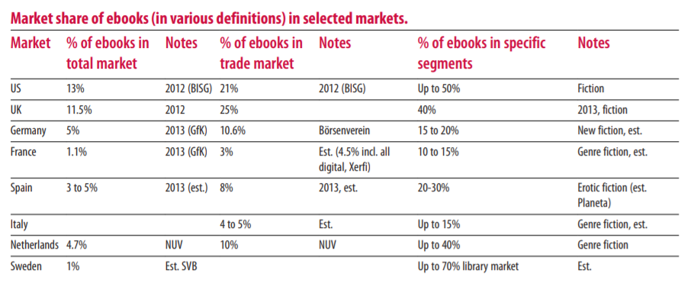

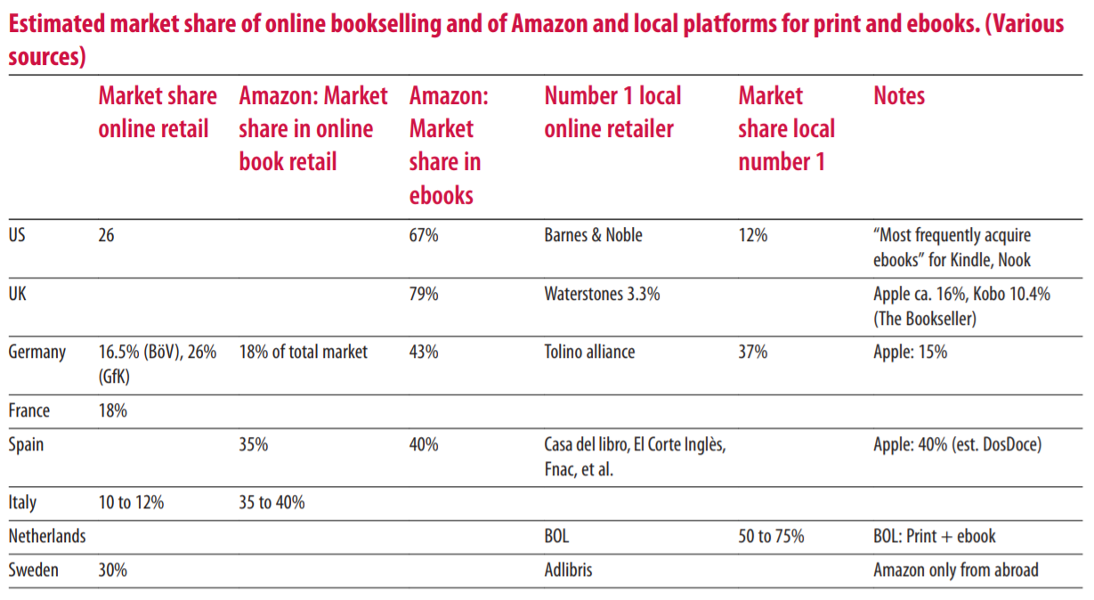

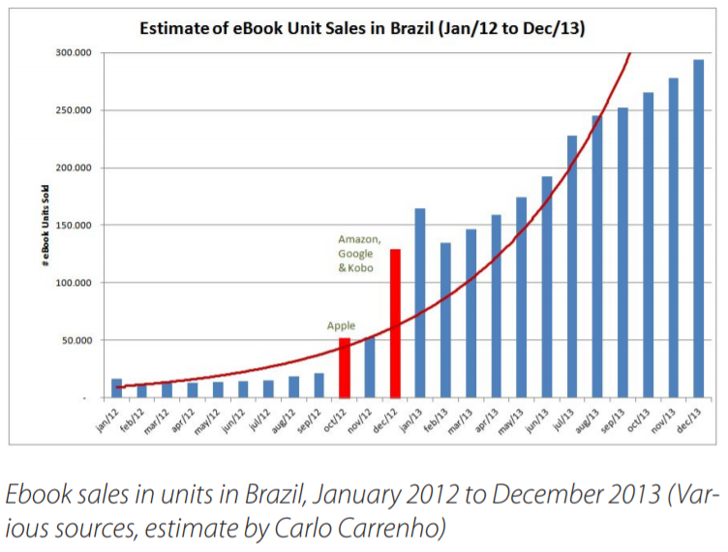

## Compare between type of books

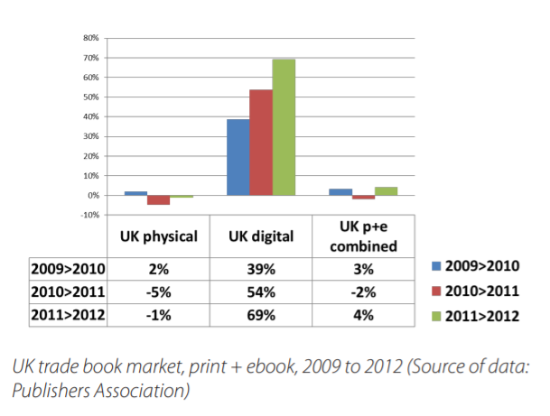

# Technology

## Android app

### Definition: Android operation system and android apps

Android operation system is a popular operation system around the world. This operating system is an open source base on Linux platform for mobile devices.

Android apps all of software which can deploy or use on Android operating system.

### Why I choose android for my project

After study about android, I decide to develop R&W app to become android app because of some reasons.

Firstly, I use an Android device which is my phone.

Secondly, I will be train about Android in next semester in my university.

Next,

Finally

## Backend technologies

### Java

According to (Chan, 2016), “Java is an object-oriented programming language developed by James Gosling at Sun Microsystems, which has since been acquired by Oracle Corporation.” Java is widely used by developers around the world. This is a language that can create products that work across multiple environments such as desktop, web, mobile devices. It means the product can work on multiple operating systems.

According to (data-flair.training, 2019) also talk about some advantages and disadvantages of java as following:

**Advantage**

* Simple: it is easy to use, compile, debug, etc. Memory allocation and garbage is automatic.
* Object-Oriented: it allows user can form standard programs and reusable code.
* Platform-Independent: it can run in all of the devices without any special software but it needs JVM.
* Distributed computing.
* Secure: there are a security manager.
* Memory allocation: there are two part of memory which is heap and stack to keep information and restore them easily.
* Multithreaded: there are many tasks are performed at the same time.

**Disadvantage**

* Performance: because Java don’t natively compile so it will consume memory and slow speed.
* Single-Paradigm Language.
* Memory Management: garbage collector can affect to performance of application because it makes other threads are stopped for running.

**Population of java**

**Why learn Java?**

According to(Chan, 2016), there are some reason why should learn java:

* Popularity: It is a widely used language with 3 billion devices running Java tape. In addition, it is also used to develop Android applications which is an operating system used for large numbers of mobile devices which increasing day by day.
* Easy to learn: For those who already have programming experience, java becomes easy when the features and syntax are like other programming languages ​​like C. For those without programming experience, it is designed to be relatively easy to learn and close to natural language.
* Write code one time to run anywhere.
* It is an OOP language.

### Kotlin

According to (Samojło, 2019), Kotlin is a statically-typed open-source programming language …

According (Samojło, 2019), Kotlin also has pros and cons as following:

**Advantages**

* Increases team efficiency: it is clear and compact. It also help to increase team efficiency because of succinct and intuitive syntax.
* Complies with existing Java code.
* Easily maintainable: because Kotlin support a large of IDES so it helps to increase developers’ productivity thank to continue use familiar toolkit.
* Less buggy: the program can be less buggy because of clear and compact codebase and stable and consistent development process.

**Disadvantages**

* Still not Java: it is similar Java but it is two different languages.
* Fluctuating compilation speed: it is faster than Java while making incremental builds. However, Java make clean builds better than Kotlin.
* Fewer Kotlin experts for hire.

**Why learn Kotlin?**

According to(Lane, 2019)**,** there are some reason why should learn java:

* Kotlin experience is in demand: there are 20% application which was built by Java before Google I/O 2017 change in Kotlin. Demand of Kotlin increase when there are more company change to use Kotlin.
* Projects will be developed faster because it is an inherently concise language so it use less lines of code.
* The quality of apps will be improved because there are the number of bugs and system failures.
* Addition existing Java libraries while coding.
* Google supports it for Android development.
* There are many resources to learn and use.

### Python

## Font-end technologies

### Kotlin

### Java

### React native

## Choosing program language

## Database language

### SQL

According to (DeBarros, 2018), SQL stand for Structural Query Language is a programming language which is widely used to define and query database. It is very useful to database when it supports to create, modify, explore, and summarize data.

According to (geeksforgeeks, n.d.), SQL also have some advantages and disadvantages as following:

**Advantages**

* Faster query database
* Don’t need coding skills
* Standardized Language
* Easy to learn and understand
* When using SQL, user can view multiple data with many times.

**Disadvantages**

#### SQL server

#### MySQL

### Mogo DB

### Choosing database language

I think I will use MySQL for my project because of some reason.

## Tool

### Android studio

### Visual Studio Code

### GitHub

### MySQL

### Draw.io

# Methodology

## Waterfall model

**Definition**

According to (Alan Dennis, 2012), waterfall model is a model which developer or user must do it step by step. This meaning, this step finish, team must move to another step. So, changing requirements or back to previous step don’t accept or it is very difficult while waterfall model applying.

**Stages of waterfall model**

According to(Tutorials Point, n.d.), there are four stages to finish a system, as following:

* Requirement analysis: all of the requirement for the project will be describe and note into a document.
* System design: requirement specifications and system design will be studied and prepared.
* Implementation: this is stage for implement system following design.
* Testing: testing is a stage to test all of system for any case.
* Deployment: after finish final product, it will be deployed customer environment.
* Maintenance: this stage will be done after product used in customer environment, if there are any changing or bug.

(Tutorials Point, n.d.) also write about advantages and disadvantages of Waterfall model, as following:

**Advantages**

* Because each stage does a clearly and specific deliverables and a review process so it is easy to apply and manage.
* Well understood milestones.
* Tasks will be clearly definition so it will be easy to arrange tasks.
* There are documents to be noted process and results, so if there are change personnel, it will be easy to hand over work.

**Disadvantages**

* This is a rigidity model because development team need to do step by step and can’t skip back previous step, so it doesn’t accept changing.
* This model isn’t suitable when apply for project which isn’t clearly requirement.
* The product only delivers in the end project.

**When Scrum is applied**

**Popularity**

## Scrum model

**Definition**

According to (Choudary, 2019), this model is a development process which follow agile method. So, it has characteristic like Agile which is iterative and incremental. To do this, during apply Scrum, project will be divided small time frames which is called sprint.

**Scrum Roles**

According to(Choudary, 2019), there are three roles in scrum, as following:

* Product owner: this person is the best person who understand about product and its requirements. Product owner can be customer or Business Analyst of software company.
* Scrum master: this person will observe and warrant, their team will follow Scrum model. There are some tasks which is scrum master’s responsibility: communicate with Product owner, training Sprint, organization events, protect and motivate team, etc.
* Development team: The team responsible for product development, it consists of software engineers working together. They need to do: analysis system, design, coding, taking part in meeting, understand and follow Scrum Process.

**Events in Scrum**

* Sprint planning: this is meeting to plan what task need to finish during a sprint.
* Daily Scrum: this is daily meeting which is about 15 minutes. They will determine what they did yesterday, what they will do and what the problem.
* Sprint review: this meeting has purpose to present team’s completed work during sprint. And it will occur when each sprint finish.
* Sprint retrospective: this is time to discuss about what went right, what went wrong, and how to improve.

**Scrum Artifacts**

* Product Backlog: this document is a list of tasks and requirements which make final product.
* Sprint Backlog: this document is a list of tasks which will be finished in the sprint. These tasks will be sorted following priority level.
* Burndown Chart: this chart will display estimated remaining work.
* Product Increment: this artifact will sum and combined all work which finish during previous sprints together.

According to (Yodiz, 2016), Scrum also have advantages and disadvantages as following:

**Advantages**

* It is easy to change because this model divides tasks into each sprint, if there are any changing, the team can change in the next sprint.
* When applying scrum, the accountability of team will be increase.
* This model also is a transparency, visibility and cost saving methodology than others.

**Disadvantages**

* The team need high skill, specially Scrum master. If Scrum master have low experienced, it will be reason to ruin project.
* It requires team have high communication skill to communicate between member and customer.
* It also needs defined task well.

**When Scrum is applied**

**Popularity**

## Choosing methodology

For my end year project, I think Waterfall model will be a good choice for me because of some reason.

Firstly, I have experience to apply Waterfall model. During study process, I have some lecture to learn about Waterfall. In the meantime, I have done research and practice of applying this model to develop some products. This has helped me to have experience in applying Waterfall in project management. The lessons I have learned will help me to apply this model more thoroughly in this project.

Secondly, there are a person to finish this project. This means that only one member performs all tasks. If using the Scrum model would not make sense when it requires lots of meetings and conversations with customers. Meanwhile this product is completely made based on my wishes and wishes without any customers or a member to conduct meetings. If the Waterfall model is applied, this problem will be solved when the work will be done sequentially and there is no need to exchange and conduct meetings during project development. It will help me to cut a large amount of work because I will not need to write documents about meeting like daily meetings.

Finally, project requirements are clearly or almost unchanged. This is my own application developed so all requirements and functions are clearly understood and it is shaped by me when developing the software so it seems that its function will not change or if any, it will be very few.

In short, in this project I will use Waterfall model for my project.

# Other Ebook product

# E-books on website

## Facebook

## Wordpress

# Similar apps

## Wattpad Apps

### Overview

According to (Wattpad, 2020), this app was pushed by Wattpad company since 2006. Nowadays, Wattpad have 80 million users. This platform allow user to get their stories. They can create own stories then share with their community who will get motivation for user’s writing journey. So they can connect with a community 80 million other readers and writers. This app also supports more than 50 languages so user can read original stories from writers around the world including a lot of types of story such as romance, science fiction, mystery, comedy, action adventure, fantasy, young adult fiction, or fanfiction. If user want to keep their favorite stories, they can add them into their own free library. Then they can find it easier.

### History of Wattpad

According to (wattpad.fandom, n.d.), there are four stages to develop as following:

**Launch and Fame**

The idea of Wattpad started in 2006. Original idea is e-book reading application when Ivan Yuen (a staff of Tira Wireless) connected with Allen Lau who is a co-founder of Tira Wireless and has same idea. Then they met Vancouver, after that they pushed unofficially Wattpad in 2006.

After that Wattpad become more popular:

* 2/2007: there were over 17000 e-books which user could use, was added app from Project Gutenberg.
* 3/2009: E-book reader for iPhone such as Amazon Kindle was competed when Wattpad had an iPhone version.
* 6/2009: there were over 5 million times to download this application.
* Day by day, Wattpad become only e-book reader which support all major mobile phone platform because Wattpad launch on BlackBerry App World (4/2009), Google Android (6/2009) and Apple iPad (4/2010).
* Nowadays, Wattpad have 80 million users.

**Criticism**

Because Wattpad gives users the freedom to post content they want to share, they have been criticized for hosting copyrighted content. To solve this problem, Wattpad has taken many practical actions including the "Authors In Charge" program. With this program, the author can identify and directly remove the infringing content from the Wattpad.

**New authors and teens**

The stories voted by readers will appear on "Hot List". Along with the popularity of these stories, their authors have also become increasingly popular and have a high position among Wattpad users. This list will be updated regularly. This is also one of the reasons for many people to believe that Wattpad has inspired children and adolescents to develop their talents in literary writing and study and discover new things through reading. Wattpad also allows easier user and author to interaction.

**Contest**

Wattpad organization a number of competitions each year. One of the major competitions held every year by Wattpad is The Watty Awards. Everyone who has a Wattpad account can take part in the award and have a great chance of winning the prize when Wattpad divides the audience into three different levels (Popular, On The Rise, and Undiscovered).

### Problem of Wattpad app

According to (wikipedia, n.d.), Wattpad also met some about copyright issues, because user can free to upload their documents so there are many users to share college theses and self-published novels so it broke copyright legal. Then Wattpad developed a function which enables authors to recognize and delete infringing material directly from the Site.

## FBReader

FBReader stand for Favorite Book Reader, this is a popular app. It supports multi-platform such as Tizen, Microsoft Windows, mobile Linux devices, etc. When using this app, users can save book in their own devices and it also supports a lot of formats such as .zip, MS Word, etc. In addition, users can choose fonts and screen brightness and 34 languages to appropriate with them. This app was written in C++, then it was remade by java since 2007. Nowadays, it is available both Android and IOS.

## Kobo Books

Kobo Books was created by a company which sells e-books, audiobooks, e-readers and tablet computers. So, there are over 6 million titles to be available for user. Users can read thousands of free eBook previews before they purchase eBooks or audiobooks on this app. Then they can use them anywhere because they can include them on any their device and keep reading. In addition, they also adjust Night-mode or size and style of text to appropriate with you.

## Amazon Kindie App

In the pass, if someone wants to books from Kindle, they need buy a new Kindle and spending a lot of money. However, nowadays user can download free app which is Amazon Kindle, then user can be comfortable read books which they buy from Amazon on their phone. In this app, there are many samples any eBook for free. Beside books, user also can read magazines, newspapers, and textbooks. They also choose reading online or offline. User also adjust font style, size, screen brightness, page color and more to appropriate their favorite.

## Bluefire Reader App

This app allow user can read eBook from retailers, publishers, and libraries around the world under protected of Adobe Content Server on user’s smart devices. They also can spread passion to read books with everyone through sharing via email or to social media. Users also are easy to search book or make a list or favorite book. The reading location will be synchronized on any devices. Beside they also highlight, bookmark, and annotate contents or books which they want to remember.

## Apple Books App

This app only is available on iPhone, so if user want to install this app, they must be an owner of iPhone. There are thousands of titles with many genres. This app is very convenient because it supports saving position which users left off or recommendations what this app think you like base on what users have been reading. Users also can choose auto-night mode or white-on-black text.

## Evaluation and conclusion

From researching above, this project will be able to high probability of success and well received by everyone. Because there are many app similar and eBooks is growing alternative to print books so the demand for a platform to allow users to read eBooks is increasing. From that the original idea become clearly. Project isn’t provided a supply of books like the Kobo books app which was developed by an e-book trading company. So, this product doesn’t have a large number of titles to choose from. The solution that this app can have a feature which allow users to be free to post in their own stories on this platform just like Wattpad did. However, it will develop a function so that users can donate to their favorite stories, so pursuing a passion can be a way to make money for many young people who have a passion for writing. Just like Wattpad, this app can be met the problem which is about copyright issues when allowing users to freely post content, so while development this project, this issue is needed to care and develop a Management functions such as user can report to request settlement. Most apps have a function so that users can adjust the screen brightness, font, background to suit the viewer. Those function will be necessary for this product, because users use the app for long periods of time to read a story. The Bluefire Reader app and Wattpad both create a list of favorite books, which will make it easier for readers to find and read. So, in this application, those function need to add into product. In addition, users can also download eBooks for offline reading. So, by exploring, some ideas and functions for this product was formed, those ideas could be developed in this project.

# Bibliography

A Developer’s First Look at Android. (2008). *Linux For You*, 48-50.

Alan Dennis, B. H. (2012). *System analysis and design.*

Chan, J. ( 2016). *Learn Java In One Day and Learn It Well .*

Choudary, A. (2019, 11 28). *What is Scrum? Everything you Need to Know about Project Management*. Retrieved from edureka: https://www.edureka.co/blog/what-is-scrum/#artifacts

*data-flair.training*. (2019, 29 7). Retrieved from data-flair.training: https://data-flair.training/blogs/pros-and-cons-of-java/

DeBarros, A. (2018). *Practiacal SQL A Beginner’s Guide to Storytelling with Data.* San Francisco.

*geeksforgeeks*. (n.d.). Retrieved from geeksforgeeks.org: https://www.geeksforgeeks.org/advantages-and-disadvantages-of-sql/

Holley, L. M. (2012). Technical Services Quarterly. *History of the Ebook: The Changing Faceof Books*, 292-311.

Lane, A. (2019, 10 16). *blog.udacity*. Retrieved from blog.udacity.com/: https://blog.udacity.com/2018/05/why-developers-should-learn-kotlin.html

Lipovac, T. (2014, 9 29). *Slide share*. Retrieved from https://www.slideshare.net/: https://www.slideshare.net/tatjanalipovac5/advantages-and-disadvantages-of-printed-and-e-books-marina-hajdukovi#:~:text=Disadvantages%20of%20printed%20books%20%E2%80%A2,and%20hard%20to%20carry%20around.&text=You%20need%20lighting%20%E2%80%93%20you%20can,a

*River Sanctuary Publishing*. (n.d.). Retrieved from www.riversanctuarypublishing.com: https://www.riversanctuarypublishing.com/our-services/about-e-books/advantages-disadvantages/

Samojło, G. (2019, 9 2). *Pros and Cons of the Kotlin Programming Language for Developing Android Apps*. Retrieved from netguru.com: https://www.netguru.com/blog/kotlin-pros-and-cons

Solutions, R. I. (2016, 5 19). *Top 5 Benefits from Android Studio 2.0 for an Android App Development Company*. Retrieved from rootinfosol.com: https://www.rootinfosol.com/top-5-benefits-from-android-studio-2-0-for-an-android-app-development-company

*Tutorials Point*. (n.d.). Retrieved from SDLC - Waterfall Model: https://www.tutorialspoint.com/sdlc/sdlc_waterfall_model.htm

Wattpad. (2020). Retrieved from apps.apple.com: https://apps.apple.com/us/app/wattpad-read-write-stories/id306310789

*wattpad.fandom*. (n.d.). Retrieved from wattpad.fandom.com: https://wattpad.fandom.com/wiki/Wattpad_History

*wikipedia*. (n.d.). Retrieved from en.wikipedia.org: https://en.wikipedia.org/wiki/Wattpad

*wikipedia.org*. (n.d.). Retrieved from en.wikipedia.org: https://en.wikipedia.org/wiki/E-book#Timeline

Yodiz. (2016, 8 1). *yodiz*. Retrieved from yodiz.com: https://www.yodiz.com/blog/kanban-vs-scrum-benefits-similarities-pros-and-cons/

<https://www.tckpublishing.com/best-ebook-apps/>